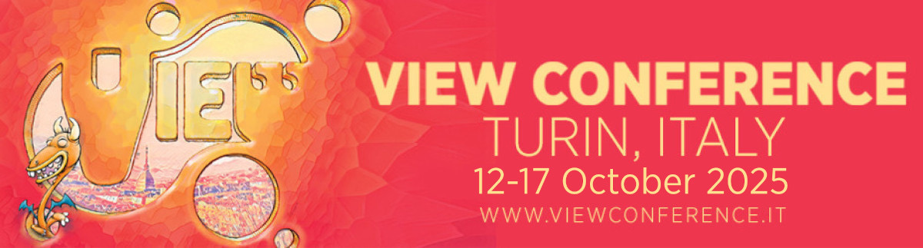
“Jurassic World Rebirth” at VIEW Conference 2025
Sink your claws into “Jurassic World Rebirth” with David Vickery, production VFX supervisor and second-unit director for the new action epic from Universal Pictures and Amblin Entertainment. In his unmissable presentation at VIEW Conference 2025, Vickery lifts the lid on the film’s spectacular visual effects and reveals how his team brought this breathtaking batch of big-screen dinosaurs to life.
In “Rebirth,” an extraction team races to the most dangerous place on Earth, an island research facility inhabited by the worst dinosaurs left behind. The mission to secure DNA from three colossal creatures becomes complicated when the team encounters a shipwrecked civilian family. Stranded on this forbidden island, they come face-to-face with a shocking discovery that has been hidden from the world for decades. Directed by Gareth Edwards, “Jurassic World Rebirth” roars into theaters July 2, 2025.

REGISTER NOW FOR VIEW CONFERENCE 2025:
https://www.viewconference.it/pages/registration

More award-winning speakers to be announced soon! Stay tuned.

ABOUT VIEW CONFERENCE 2025
Celebrating 25 years of success, VIEW Conference 2025 takes place from October 12-17, 2025, in the gorgeous baroque city of Turin, Italy. This premier international event offers a unique chance to network with award-winning film directors, animators, artists and game designers as they deliver an incredible program of keynotes, panels, talks, workshops and masterclasses. Explore cutting-edge thinking with a stellar line-up of stars from Hollywood and Silicon Valley as they celebrate the latest achievements in Animation, VFX and Games, and share unforgettable visions of the future. VIEW Conference 2025 is an English language event. Registration now open.

BOOK YOUR TICKETS NOW:
https://www.viewconference.it/pages/registration

ABOUT DAVID VICKERY
David Vickery is a BAFTA and VES Award-winning Visual Effects Supervisor who also serves as the Creative Director of ILM’s Mumbai studio. With over 20 years of extensive experience, Vickery led effects as Head of Department and Production Visual Effects Supervisor on the “Jurassic World” franchise, “Mission: Impossible – Rogue Nation,” and “Fast & Furious 6.” His work has been recognized with an Academy Award nomination and a BAFTA Film Award win for Special Visual Effects for “Harry Potter and the Deathly Hallows: Part 2,” in addition to numerous Visual Effects Society Award nominations and wins. Before joining ILM, Vickery was a Senior Visual Effects Supervisor at Double Negative. Having strong ties to the visual effects community in London, Vickery formerly sat as Co-Chair on the United Kingdom’s board of the Visual Effects Society and is a member of the Academy of Motion Picture Arts and Sciences and the British Academy of Film and Television Arts.

For more information:
https://www.viewconference.it
Facebook: https://facebook.com/viewconference
YouTube: https://youtube.com/c/viewconference
X: @viewconference
Instagram: view_conference
Bluesky: @viewconference.bsky.social
VIEW Conference newsletter: Sign up here
#viewconference2025

