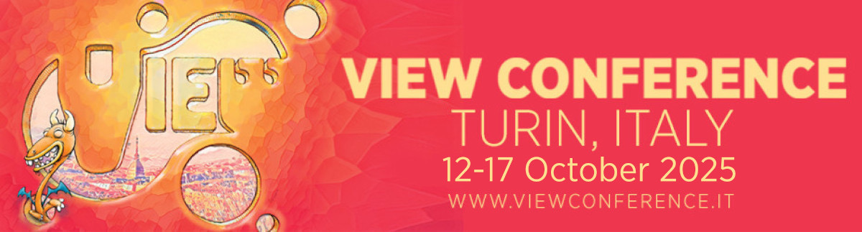

Writer/Director Alessandro Carloni Presents a behind-the-scenes look at “The Cat in the Hat” at VIEW Conference 2025

Torino, Italy – VIEW Conference is delighted to announce that Alessandro Carloni, writer/director of Warner Bros. Pictures Animation’s upcoming animated feature “The Cat in the Hat,” will attend VIEW Conference 2025. This year’s conference takes place from October 12-17, 2025, in the stunning baroque city of Turin, Italy.

Written and directed by Alessandro Carloni and Erica Rivinoja, “The Cat in the Hat” is due for release in theaters February 27, 2026. Carloni’s special behind-the-scenes presentation at VIEW Conference 2025 gives attendees an incredible early look at elements of this highly anticipated film.

Meet the Cat in the Hat you don’t know! In the wonderfully whimsical tradition of Dr. Seuss, “The Cat in the Hat” comes to the big screen in his animated theatrical feature film debut, an all-new, epic adventure with an edge, where mischief, magic and mayhem reign supreme. Doing what he does best, the Cat—voiced by Bill Hader—spreads joy to kids in his hilarious, signature and singularly irreverent way, transporting them and audiences on a fantastical journey through a world they’ve never seen before. It is the first in a planned Warner Bros. Pictures Animation series of Dr. Seuss films, andfeatures an innovative combination of animation styles.

Tickets for VIEW Conference 2025 are now available from the official website:
https://www.viewconference.it/pages/registration

“We are so excited to present this peek at the making of ‘The Cat in the Hat’ at VIEW Conference 2025,” says Conference Director Dr. Maria Elena Gutierrez. “Director Alessandro Carloni has an incredible track record as a filmmaker, and his new movie promises to be something truly special.”

About Alessandro Carloni
Alessandro Carloni is a film director, writer, and artist. He studied literature in Italy, where he first worked as a writer and musician before entering the world of filmmaking, directing commercials, music videos and short films in studios throughout England, Germany, and Denmark. He moved to the United States in 2002, where he worked at DreamWorks Animation as head of story, head of animation and eventually director on the iconic animation franchises “Kung Fu Panda” and “How to Train Your Dragon.” He is currently creating and writing an original TV series for Netflix, and writing and directing “The Cat in the Hat” for Warner Bros. Pictures Animation.

About VIEW Conference

An English language event, VIEW Conference 2025 takes place from October 12-17, 2025, in the beautiful baroque city of Turin, Italy. Enjoy this unrivaled opportunity to network with award-winning film directors, animators, artists and game designers as they deliver an incredible program of keynotes, panels, talks, workshops and masterclasses. Explore cutting-edge thinking in a wide range of creative and technology-based fields as a stellar line-up of stars from Hollywood and Silicon Valley. Celebrate the latest achievements in Animation, VFX and Games and share unforgettable visions of the future.

The conference’s vibrant and inclusive atmosphere is designed to enlighten and inspire, with an extensive live program of talks, presentations, workshops and masterclasses embracing cutting-edge thinking on such diverse topics as Storytelling, Virtual Production, Computer Graphics, Interactive & Immersive Media, VR/AR/Mixed Reality and the Metaverse, Artificial Intelligence, Real-Time Rendering and much, much more.

Please consider donating whatever you might be able to afford to help keep VIEW Conference going strong. No amount is too little to make a difference. Thanks for your support. You can donate while registering for this event, or by visiting the VIEW Conference website.

For more information:
https://www.viewconference.it
Facebook: https://facebook.com/viewconference
YouTube: https://youtube.com/c/viewconference
X: @viewconference
Instagram: view_conference
VIEW Conference newsletter: Sign up here
#viewconference2025

