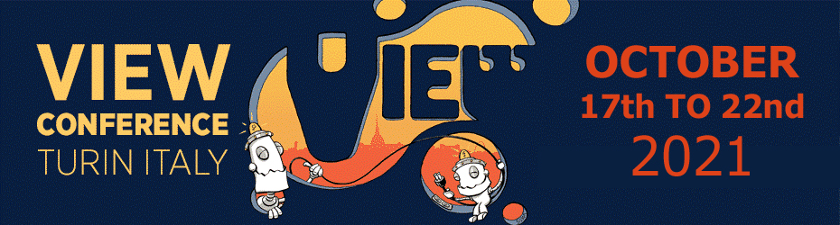

VIEW CONFERENCE
October 17-22, 2021
For immediate release:

Award-Winning Filmmakers Dominate the First Group of Speakers Confirmed for VIEW Conference 2021

Torino, Italy – VIEW Conference is delighted to unveil the first group of speakers confirmed for this year’s event.

VIEW Conference 2021, the 22nd edition of Italy’s premiere animation, VFX and computer graphics conference, takes place from October 17 to 22, in the beautiful city of Torino, Italy. Industry professionals, students and enthusiasts are invited to attend on-site at Torino’s spectacular OGR venue. In addition, online access opens up the event to a global audience.

Purchase tickets for VIEW Conference 2021 at the official website:
https://www.viewconference.it/pages/registration

VIEW Conference welcomes keynote Speaker Academy Award nominee Tom McGrath, director of this year’s hit animated feature film The Boss Baby: Family Business, his sixth movie for DreamWorks Animation. A graduate of the Cal Arts Character Animation program, McGrath is the co-writer and director of the Madagascar movie franchise along with Eric Darnell. He went on to direct Megamind in 2010 and the Academy Award nominated The Boss Baby in 2017. His films have generated 2.8 billion dollars at the box office worldwide.

Also from the world of feature animation comes Tomm Moore, co-founder of Cartoon Saloon and director of the Oscar ©nominated Wolfwalkers. Also attending are Kris Pearn, director of The Willoughbys and Cloudy with a Chance of Meatballs 2, and Brad Lewis, producer of films including How to Train Your Dragon: The Hidden World and The Lego Batman Movie, along with Kim White and Deanna Marsigliese, director of photography and character art director of Luca, this summer’s feelgood animated feature from Disney and Pixar.

This year’s visual effects speakers include Sean Walker, Weta Digital’s VFX supervisor on Marvel Studios’ and Disney’s Shang-Chi and the Legend of the Ten Rings and, also from Weta Digital, VFX supervisor Luke Millar talking about Disney’s Jungle Cruise. VIEW Conference is also thrilled to welcome VFX supervisor Scott Squires, whose extraordinary career spans films from Star Trek: The Motion Picture and Blade Runner to Star Wars: The Phantom Menace and beyond, plus VFX supervisors Volker Engel and Douglas Smith, both Oscar-winners for Independence Day and veterans of countless blockbuster features. And don’t miss legendary animator and visual effects supervisor Phil Tippett, whose credits include the Star Wars original trilogy, Jurassic Park and Starship Troopers, not to mention his hallucinatory passion project Mad God.

Animation in visual effects is represented by animation directors Rob Coleman – whose work includes not only the Star Wars prequel trilogy and Peter Rabbit, but also animated features like Happy Feet Two and The Lego Movie – and ILM’s Hal Hickel, another Star Wars veteran whose recent work on The Mandalorian earned the VFX team a Primetime Emmy award. From Mackevision come VFX producer Heiko Burkardsmaier and VFX supervisor Juri Stanossek, whose work encompasses productions such as The Nevers, Star Trek: Discovery and Game of Thrones.

Bringing their wealth of experience to VIEW Conference 2021 are production designer Oliver Scholl – whose credits include Edge of Tomorrow, Spider-Man: Homecoming and Venom – and Patrick Tatopoulos, production designer of Zack Snyder’s Justice League and Maleficent: Mistress of Evil, and creature concept designer on such classic films as Independence Day and Pitch Black.

In addition, VIEW Conference 2021 is thrilled to welcome a wide range of experts from the games industry, including Oscar-winning animation pioneer Glenn Entis, Vicki Dobbs Beck, Vice President of Immersive Content Innovation at ILMxLAB, andNordeus Lead Game Artist Nikola Damjanov. Pixar representatives include Chief Technology Officer Steve May and RenderMan specialist Dylan Sisson. Also attending are Eloi Champagne, Technical Director at Montreal’s NFB Animation Studio, plus author and behavioural design expert Tim Versnel.

“The list of speakers attending VIEW Conference 2021 is truly out of this world,” says Conference Director Dr. Maria Elena Gutierrez. “What’s more, it is growing all the time. Believe me when I say this first announcement is only the beginning. We have so many other talented people lining up to share their experiences, to offer profound insights into their creativity and technical prowess, and to inspire students and professionals alike. Inspiration is what VIEW Conference is all about, and I cannot wait to reveal our full programme of exciting events for 2021.”

About VIEW Conference 2021
The international VIEW Conference, Italy’s premiere event for Computer Graphics, Interactive & Immersive Media, Animation, Visual Effects, Games, Real-time Rendering, Virtual Production, AI, VR, AR, and Mixed Reality, brings top professionals from those fields to the beautiful baroque city of Torino, Italy for a week of talks, presentations, and workshops. The 2021 VIEW Conference will take place from October 17 to 22 in Torino’s state-of-the-art OGR venue, and virtually.

For more information:
https://www.viewconference.it
Facebook: https://facebook.com/viewconference
YouTube: https://youtube.com/c/viewconference
Twitter: @viewconference
Instagram: view_conference
VIEW Conference newsletter: Sign up here
#viewconference2021

