For immediate release

PRESS RELEASE – 13-JULY-2020

Get Ready for VIEW Conference 2020’s third FREE on-line session

PreVIEW III

Pixar’s RenderMan Evangelist Dylan Sisson
in conversation with Ian Failes, vfx journalist and editor of BeforeandAfters.com

Friday, July 24.
2:30pm PDT/11:30pm CET/7:30am Sydney

Pixar is known for the studio’s award-winning, blockbuster animated films, but the studio also created and continuously enhances its RenderMan software. Artists in visual effects and animation studios all over the world, as well as those at Pixar, use RenderMan to turn 3D models into believable, realistic objects and characters. The surfaces of every object and character in a Pixar movie – from Woody’s bluejeans to Coco’s stunning marigold bridge, to Onwards flying pink unicorn – were created by artists using RenderMan.

In PreVIEW III, Pixar’s Dylan Sisson will speak about the latest tech in Pixar's RenderMan. From making movie magic in Pixar’s latest feature animation Onward to looking ahead at the amazing NPR tools (non-photorealistic rendering) currently in development at Pixar that promise to transform RenderMan into a tool for any type of look, from photorealistic images to practically any other style, including comics, anime, and painterly looks.

Dylan Sisson is a digital artist with over 25 years of experience in VFX and animation, who began his career animating commercials and creating RPGs for the Sony Playstation. After Dylan’s independent animation won the award for “Best Computer Animated Short” at the AnimarFestival in 1999, Dylan joined Pixar Animation Studios where he has been engaged in the evangelization of Pixar’s RenderMan. Dylan is also the creator and designer of the RenderMan Walking Teapot. In addition to his role at Pixar, today Dylan is an active artist exploring emerging media in VR and 3D printing.

To join the free session, use this link:
http://www.viewconference.it/pages/sisson-renderman

To ask questions in advance use the write to: info@viewconference.it or use the #viewconference hashtag.

PreVIEW III is organized by VIEW Conference in partnership with OGR_Toirno and BeforesandAfters.com

The international VIEW Conference, Italy’s premiere event for Computer Graphics, Interactive and Immersive Storytelling, Animation, Visual Effects, Games, and VR, AR, and Mixed Reality, brings top professionals from those fields to the beautiful baroque city of Torino, Italy for a week of talks, presentations, and workshops.

The 2020 VIEW Conference will take place from October 18 to 23 in Torino’s state-of-the-art OGR venue and virtually.

Register to participate Please join us!
https://www.viewconference.it/pages/registration/

For more information:
https://www.viewconference.it

Sign up for the VIEW Conference newsletter here.
Facebook: https://facebook.com/viewconference
YouTube: https://youtube.com/c/viewconference
Twitter: @viewconference
Instagram: view_conference
#viewconference2020

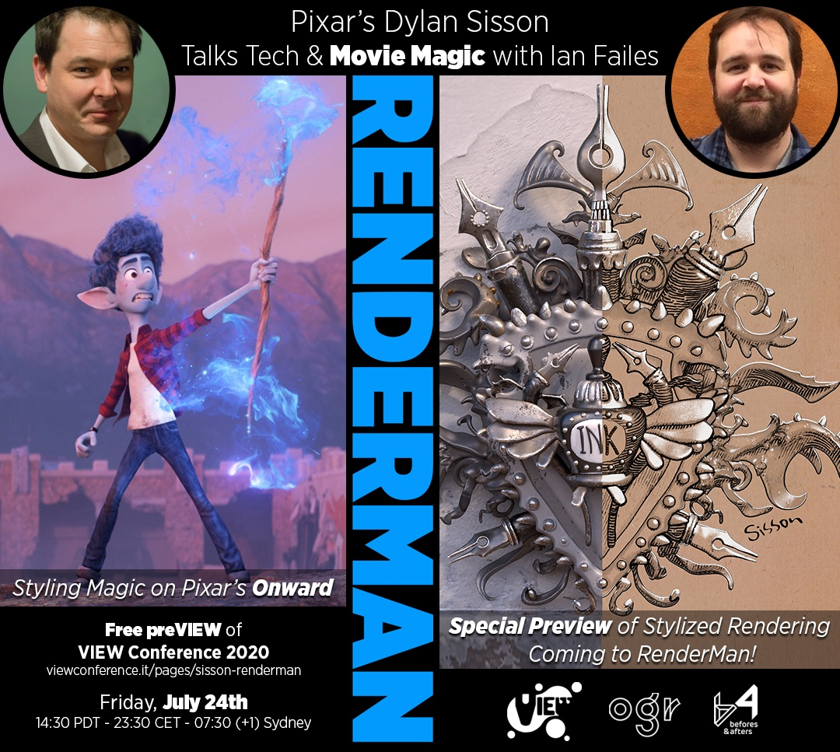
Download this image from here
http://media.viewconference.it/press_2020/Banners/ preview-sisson-july24.jpg

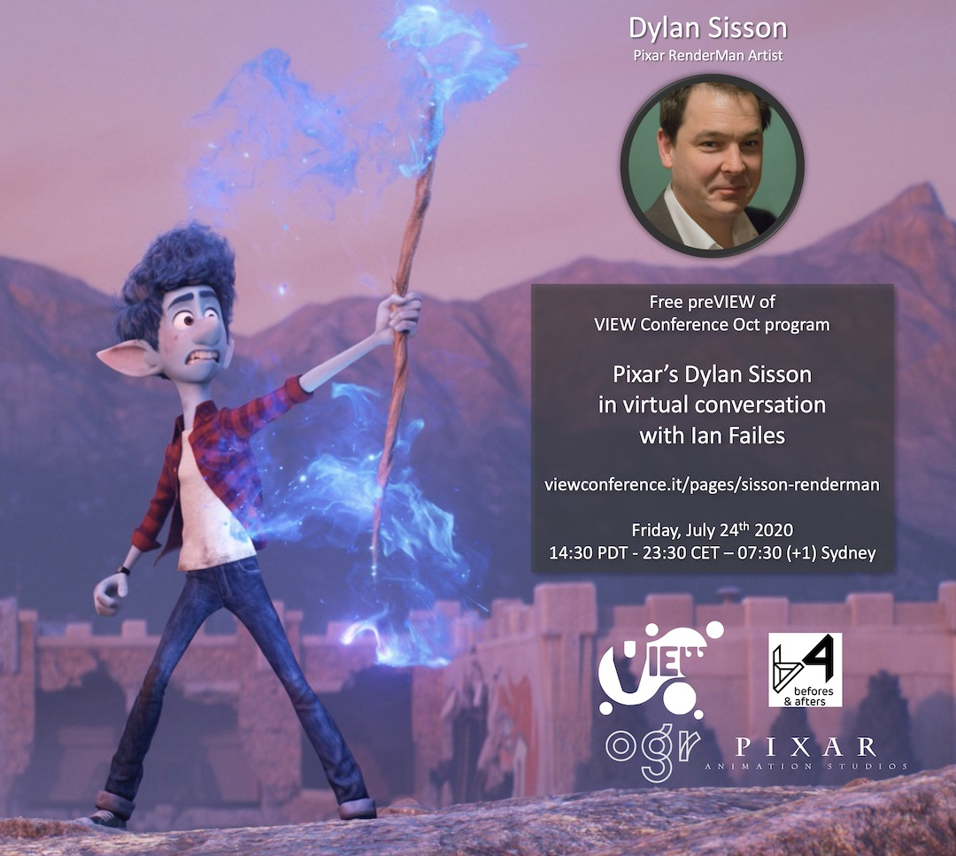

You can download this image from here:
http://media.viewconference.it/press_2020/Banners/DylanSissonSocial.jpg

