For immediate release

PRESS RELEASE – 3-JULY-2020

VIEW CONFERENCE 2020 Announces its Second Free Online Session PreVIEW II:

SAVE THE DATE: Saturday, July 11,
10:00am PDT/1pm Canada/ 19:00 CET

Award-winning Animated Feature Film Directors
Kris Pearn and Jorge R. Gutiérrez in Conversation

VIEW CONFERENCE 2020’s second FREE online session is one you won’t want to miss. During a one-hour virtual discussion, director and writers Kris Pearn and Jorge R. Gutiérrez consider each other's approach to developing and directing an animated feature.

Kris Pearn is a director, executive producer, writer, storyboard artist, and actor known most recently for writing and directing Netflix’s critically acclaimed animated feature The Willoughbys. He was nominated for a BAFTA Children’s Award for directing the animated feature Cloudy with a Chance of Meatballs 2, and received two Annie Award nominations for storyboarding the feature films Arthur Christmas and Open Season. He has also been a storyboard artist for Shaun the Sheep Movie, Home, Solo: A Star Wars Story, and Surf's Up among other films.

Jorge R. Gutiérrez is a director, writer, character designer, voice actor, known for the Annie Award winning and Golden Globe nominated animated feature film, The Book of Life produced by Guillermo Del Toro; his Annie nominated VR short film “Son of Jaguar” for Google; creating (with wife Sandra Equihua) the Annie and Emmy winning series "El Tigre: The Adventures of Manny Rivera” for Nickelodeon and his current project, the Netflix limited series “Maya and the Three.” Gutiérrez has also received an Annie award for character design and Annie nominations for writing and directing The Book of Life; an Emmy Award for character design and an Annie Award for best series for “El Tigre: The Adventures of Manny Rivera”. Gutierrez is currently developing multiple unannounced projects for Netflix Animation.

To join the free session, use this link:
http://viewconference.it/pages/jorge-and-kris

Ask questions by writing to: info@viewconference.it

PreVIEW II is organized by VIEW Conference in partnership with OGR.

The international VIEW Conference, Italy’s premiere event for Computer Graphics, Interactive and Immersive Storytelling, Animation, Visual Effects, Games, and VR, AR, and Mixed Reality, brings top professionals from those fields to the beautiful baroque city of Torino, Italy for a week of talks, presentations, and workshops.

The 2020 VIEW Conference will take place from October 18 to 23 in Torino’s state-of-the-art OGR venue and virtually. Registration is now open.at https://www.viewconference.it/pages/registration/
Please join us!

For more information:
https://www.viewconference.it

Sign up for the VIEW Conference newsletter here.

Facebook: https://facebook.com/viewconference

YouTube: https://youtube.com/c/viewconference

Twitter: @viewconference

Instagram: view_conference

#viewconference2020

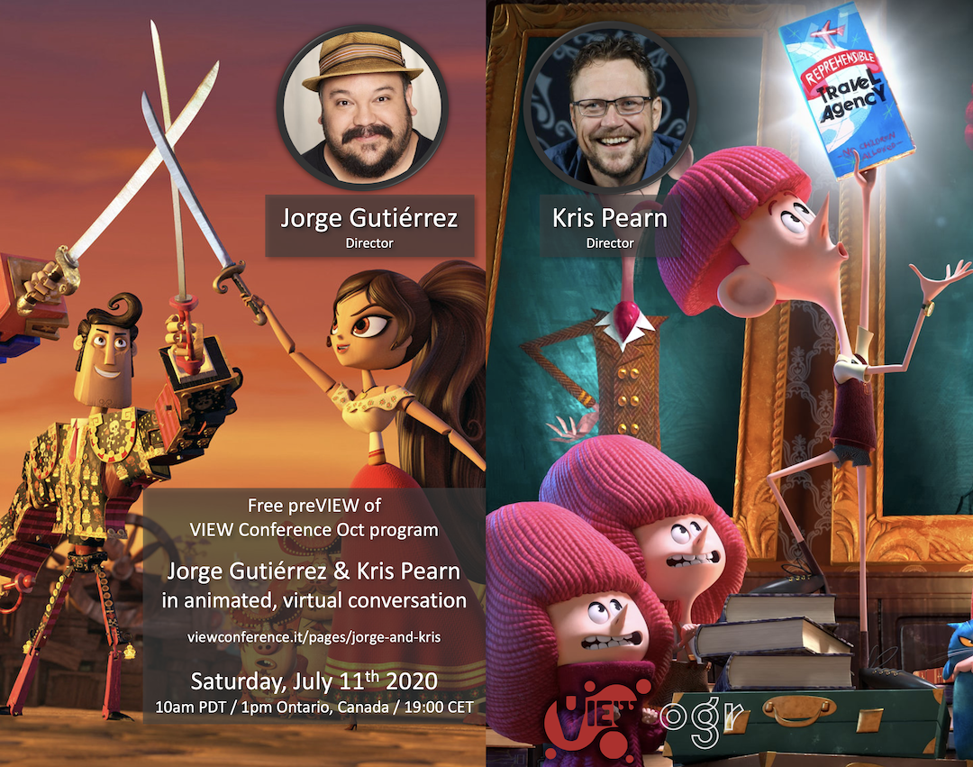

You can download this image from here:
http://media.viewconference.it/press_2020/Banners/JorgeKris_Social2.png

