VIEW CONFERENCE October 18-23, 2020

VIEW Conference Stages free online event with “Spider-Man: Into the Spider-Verse” co-director Peter Ramsey

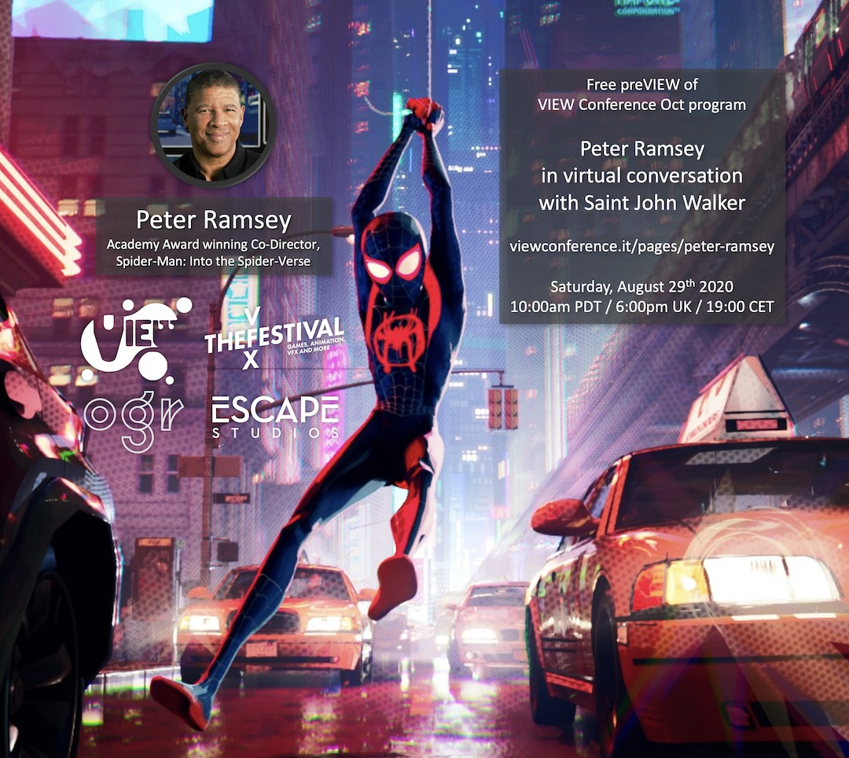
Torino, Italy – Registration is now open for an exclusive online event in which Academy Award®-winning director Peter Ramsey discusses his extraordinary career journey, including his highly acclaimed recent work as co-director of Spider-Man: Into the Spider-Verse. “Peter is a master storyteller,” says Conference Director Dr. Maria Elena Gutierrez. “Listening to him speak about his passion for making movies is a privilege.”

During this live session – one of a series of special PreVIEW sessions leading up to this year’s annual VIEW Conference in October – Ramsey will be in virtual conversation with Saint John Walker, Deputy Dean and Director, Escape Studios. He will also be responding to a selection of questions submitted by attendees on our website during the session.

This dynamic event takes place on Saturday, August 29th, 2020 at 10:00am PDT / 6:00pm UK / 19:00 CET, and will be streamed live to a global audience. Registration is absolutely free.

In his early career, Ramsey worked as a storyboard artist on an impressive catalog of live-action features including Backdraft, Boyz n the Hood, Bram Stoker's Dracula, Minority Report, Cast Away, Independence Day, Being John Malkovich, Fight Club, Hulk, and many others. Ramsey graduated to the role of second unit director on features including Godzilla, Tank Girl, Higher Learning and Poetic Justice.

In 2012, Ramsey made his feature directorial debut with the DreamWorks animated feature Rise of the Guardians. Together with co-directors Bob Persichetti and Rodney Rothman, he received an Academy Award® for Sony Pictures Animation’s Spider-Man: Into the Spider-Verse, which won the Oscar® for Best Animated Feature Film in 2018. Ramsey is the first African-American to be nominated for, and to win, an Oscar® in this category. At the Annie Awards, the same directorial team picked up the award for Outstanding Achievement for Directing in an Animated Feature Production.

In his recent New York Times article, Seeing Paradise From Behind a Dashboard, Peter Ramsey reflects on the influence of his formative years spent watching drive-in movies in Los Angeles, where he still lives and works today: “Decades later, I found myself as one of the directors of Spider-Man: Into the Spider-Verse. Watching shots and giving notes in our digital dailies, I constantly imagined myself as a child, sitting in a darkened theater and watching Miles Morales (who actually looked something like me, which is a whole other thing) and his friends up onscreen, their moments of bonding, of heartbreak, of triumph, of heroic sacrifice. Young me, seeing that up on a gigantic screen? I know it would have been absolutely everything. I can barely comprehend how the dream I had as a child, to be part of that magic, has somehow come true.”

Read the complete article in the New York Times here:
https://www.nytimes.com/2020/07/02/movies/drive-ins-movies-peter-ramsey.html

We recently did an interview with Peter Ramsey and you can check it out here:
https://www.youtube.com/watch?v=AaER0UqWQbw&feature=youtu.be

To join this free PreVIEW session with Peter Ramsey, please use this link:
https://www.viewconference.it/pages/peter-ramsey

Submit your questions for Peter Ramsey by writing to:
info@viewconference.it

PreVIEW IV is organized by VIEW Conference in partnership with OGR (Officine Grandi Riparazioni), VFXFestival and Escape Studios.

About VIEW 2020

The international VIEW Conference, Italy’s premiere event for Computer Graphics, Interactive & Immersive Media, Animation, Visual Effects, Games, Real-time Rendering, Virtual Production, AI, VR, AR, and Mixed Reality, brings top professionals from those fields to the beautiful baroque city of Torino, Italy for a week of talks, presentations, and workshops.

The 2020 VIEW Conference will take place from October 18 to 23 in Torino’s state-of-the-art OGR venue and virtually. “Because VIEW Conference will be online as well as onsite this year, we are taking advantage of the wonderful opportunity to include remarkable professionals from all over the globe,” says Conference Director Dr. Maria Elena Gutierrez. “VIEW 2020 will be amazing.”

Registration is now open. Please join us!
https://www.viewconference.it/pages/registration/

For more information:

https://www.viewconference.it
Facebook: https://facebook.com/viewconference
YouTube: https://youtube.com/c/viewconference
Twitter: @viewconference
Instagram: view_conference
VIEW Conference newsletter: Sign up here
#viewconference2020

